|  |
| --- |
|  |
| August 2021 Newsletter |
|  |

Cy-Fair FFA

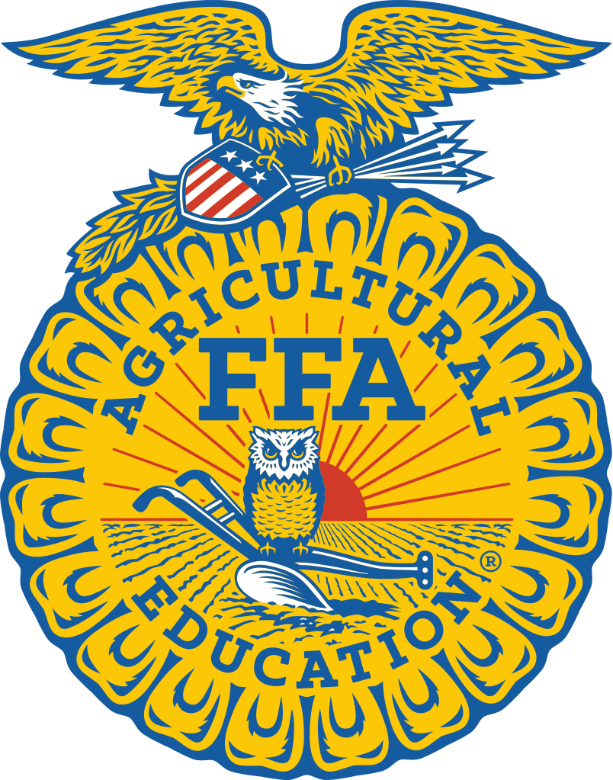

# Upcoming Events

## August 31

-Mandatory Greenhand Camp

*Required for all first year FFA Members

3-5pm in the cafeteria

-Ag Open House **Cafeteria 5pm**

*Required for all 1st year members and their parents (dinner provided)

-Animal Info Meetings **Cafeteria 6pm**

*Required for all 1st year raisers and their parents

## September 3

Greenhand Officer Application due

*For any first year member wanting an officer position in the FFA*

## September 9

CFISD Lamb, Goat & Hog entries and barn app. due

**September 14**

-Lamb/Goat Raisers Meeting

*6:30pm Library, for anyone raising a CFISD Goat or Lamb*

-Swine Raisers Meeting

*6:30pm teaching theatre, for anyone raising a CFISD pig*

-FFA Meeting

* **FFA meeting in the cafeteria and Booster club meeting in the library at 7:00pm.**

**\*For all students enrolled in an Ag class**

|  |
| --- |
|  |
|  |

22602 Hempstead Hwy Cypress, Texas 77429

W: cyfair.ffanow.org T: 281-897-4460

|  |
| --- |
|  |
| Hello Cy-Fair FFA!  Welcome to a new school year! We are looking forward to another successful year of many opportunities and new experiences. Throughout the summer, the officers have been working hard to make this year a success. Please be sure to visit our website to view our upcoming events for the year.  Sincerely,  The Cy-Fair Ag. Teachers |
|  |

## 2020-2021 Year in Review

**CFISD Livestock Show**

Grand Champion Market Rabbits: Caleb Lee

Grand Champion Lamb: Jessica Donalson

Grand Champion Ag Mech: Weston Coleman & Mikala Reiland

Grand Senior Buck Breeding Rabbit: Sarah Abell

Reserve Junior Doe Breeding Rabbit: Audrey Jordan

Reserve Champion Swine Showmanship: Reese McDaniel

Reserve Champion Steer Showmanship: Emma Morgan

Grand Champion Heifer Showmanship: Kyleigh Emerson

Reserve Champion Heifer Showmanship: Alyssa Simpson

Cy-Fair FFA Received the Gold Chapter Rating for the National Chapter Award and two star at the National Level

**Career Development Events**

Livestock Evaluation:1st in District, 3rd in area, State Qualifier

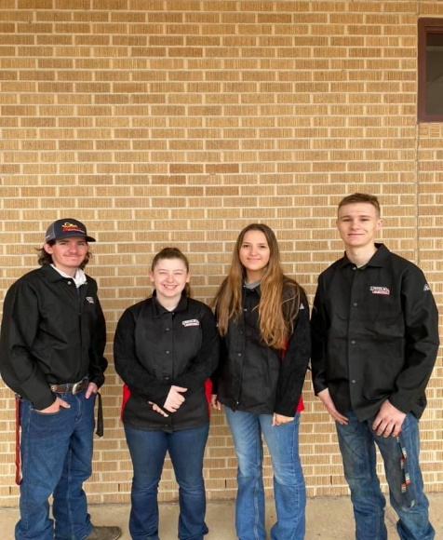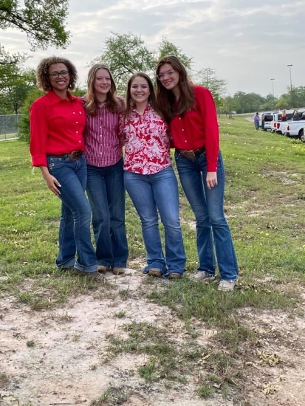Ag Mechanics: 1st in District, 2nd in area, State Qualifier

**Speaking Development Events**

|  |
| --- |
|  |
| Meet your officers President: Jessica Wargo  Vice-President: Kylie Carter  1st Vice President: Justin Chisholm  1st Vice President: Avery Florez-Poreda |

Spanish Creed: *1st in District, 3rd in Area*

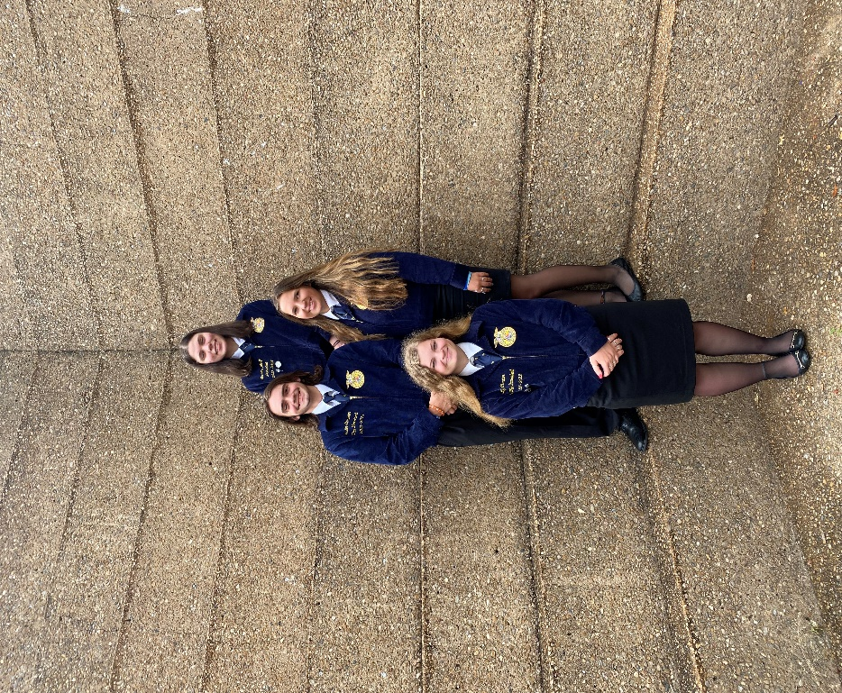Alondra Rodriguez

Prepared Speaking Plant Science: 2nd *in District, Area Qualifier*

Jessica Wargo

Prepared Speaking Ag Business: *3rd in District, Area Qualifier*

Kylie Carter

Prepared Speaking Natural Resources: *3rd in District, Area Qualifier*

Alayne Stancik

Prepared Natural Resources: *4th in District*

Zoey Casey

Prepared Speaking Ag Policy: *4th in District*

Alondra Rodriguez

Jr. Prepared Public Speaking:

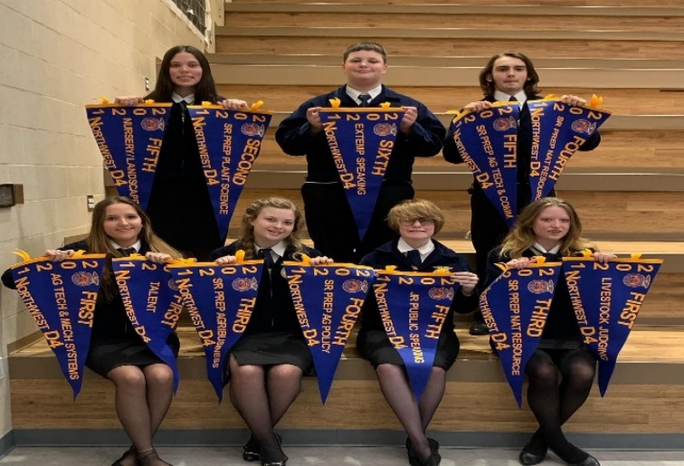*5th in District*

Julie Hawkes

Prepared Tech & Comm

*5th in District*

Jacob Wargo

Extemporaneous Public Speaking:

*6th in District*

Garrett Lawson

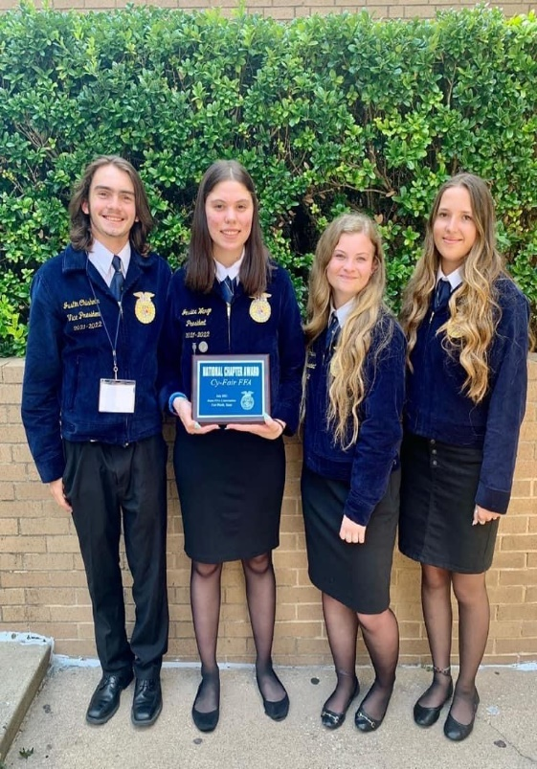**Summer 2021**

FFA Talent: *1st in District,1st in Area, top 12 in the state*

Sophie Lee

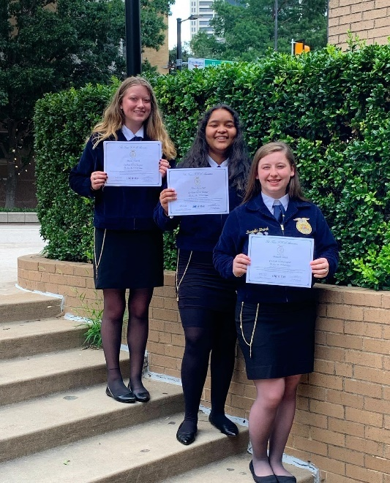

HLSR Calf Scramble Certificate Winner:

Alyssa Simpson

Lonestar Degree Recipients:

Danielle Brock, Alexa Slaughter, Alayne Stancik, Debbie Holley (Not pictured)

Cy-Fair FFA Received Silver in the Golden Horizon Award for Multiple Teacher Departments